**Machine Learning - Based Web Application Documentation**

1. Introduction 🚀

1.1 Overview

Welcome to our machine learning-powered web application, designed to supercharge your data analysis and data science projects. Our mission is to simplify complex data science tasks and empower users to explore, analyse, and model their data effortlessly. 💡

1.2 Objectives and Goals

Our primary objectives are to eliminate coding hassles and help users:

* Automate redundant data science tasks. 🤖
* Effortlessly analyse and visualize data. 📊 📈
* Simplify data preprocessing. 🧹
* Train machine learning models without coding. 🤖📚
* Save and interpret their models with ease. 💾

2. Accessing the Application 🌐

2.1 Web-App Link

You can access our application through the following link: [Web-App Link](http://35.200.189.159:8000/signin/).📌

(Works best in **Laptop/Desktop** or in **Mobile phones** with **Horizontal screen )**

2.2 YouTube Tutorial

For a detailed step-by-step guide, check out our YouTube tutorial: [YouTube Tutorial](https://www.youtube.com/watch?v=OSOW3LLVVC0). 🎥

2.3 Guest Access

We offer a seamless experience where you can continue as a guest without the need for account creation. 🙌

3. Application Workflow 🔄

3.1 Data Upload

To embark on your data analysis journey:

* **Upload Your Data**: Simply upload your dataset in CSV format. It's quick and easy! 📁

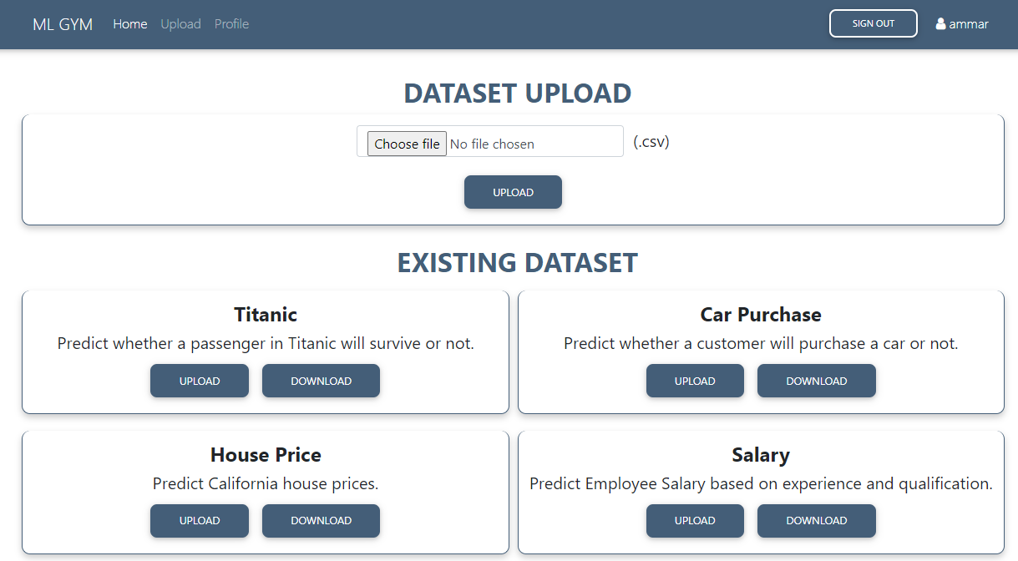

3.2 Explore Your Data

Our application swiftly analyses your dataset and provides:

* **Insightful Visualizations**: Explore your data with ease through textual, tabular, and graphical visualizations. 📈📊📋

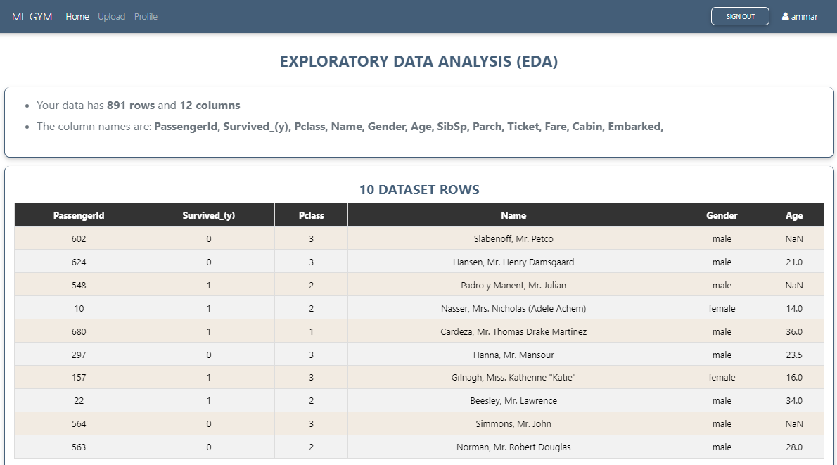

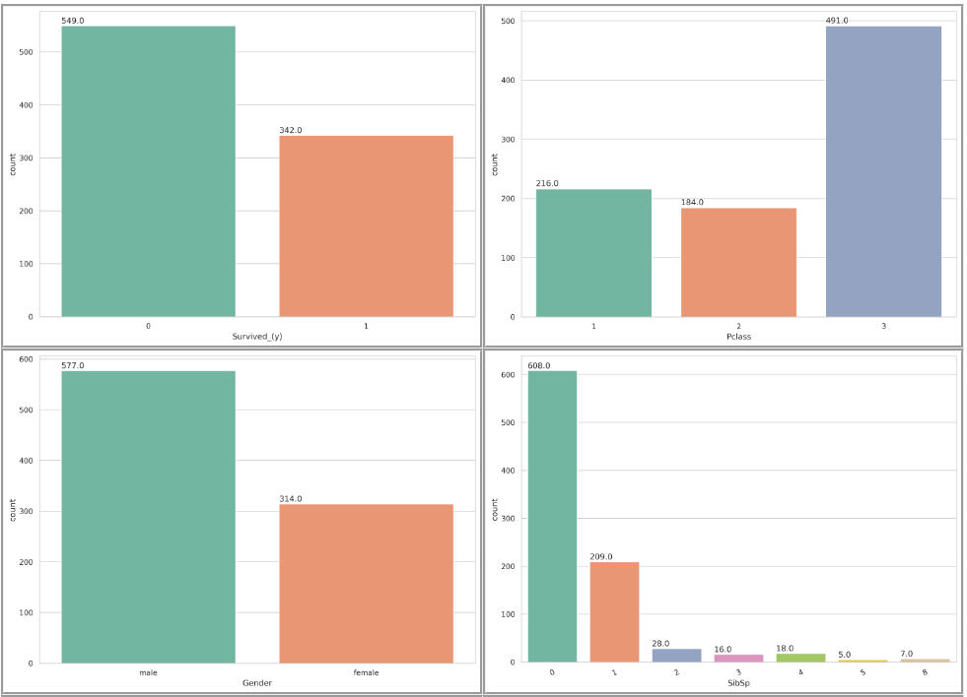

3.3 Effortless Data Preprocessing 🧹

* **Handle Missing Values**: Use radio buttons to handle missing data effortlessly. 📻
* **Train-Test Split**: Set your train-test split ratio with an intuitive slider. 🔄
* **Select Dependent Variable**: Easily choose the dependent variable from a dropdown menu.

3.4 Train Your Model 🤖

With just a few clicks, you can create your machine learning models using various algorithms:

* **No Coding Required**: Select a model from the dropdown menu containing several ML Algorithms and click to train. 🧰📚

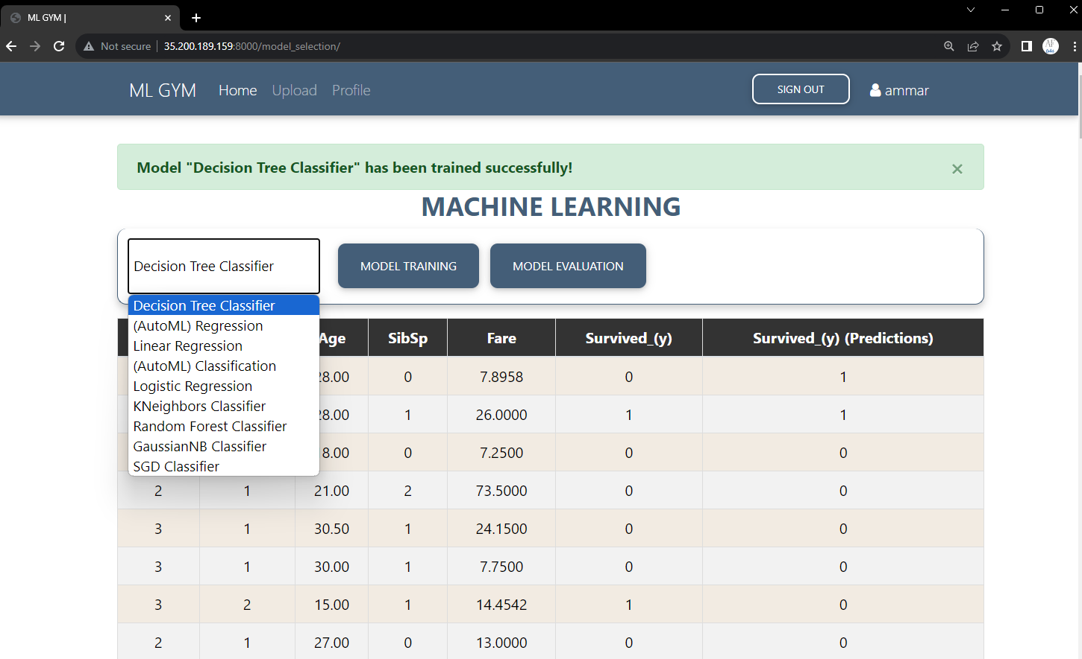

* **Model Evaluation**: See immediate model evaluation to assess its performance. 📈📊

3.5 Save Your Model 💾

Once you've perfected your model:

* **Effortless Saving**: Save it for future use and interpretation.

* **Model Testing:** Access your saved models in your profile for testing on custom inputs. 📦🔐

3.6 Interpret Your Results 📈

Gain valuable insights into your model's predictions and understand how it makes decisions:

* **In-App Analysis**: Dive into your results and interpret them right within the application. 🧐🔍

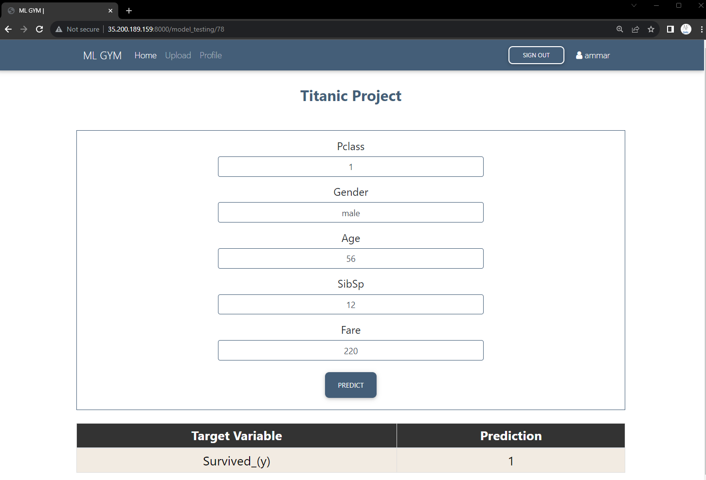

3.7 Future Improvements 🚀🌟

Here's what's coming up next in our exciting roadmap:

* **Graphical Analysis 📊👀:** Users will soon be able to craft custom graphs between various dataset columns for in-depth insights at the click of a button. 📈🖱️
* **Tabular Analysis 📑🔍:** Get ready to interact with your dataset using conversational queries that will return neatly organized tables filled with your data. 🗣️➡️🏓
* **Custom Preprocessing ✂️🔄:** We're introducing tools to help you easily identify and remove outliers from your dataset's columns, ensuring cleaner data for analysis. 🧹📊
* **ML Parameters Selection ⚙️🤖:** Tinker to your heart's content with machine learning model parameters for a tailored and optimized predictive model. 🔧🧠
* **Forecasting 📆🔮:** Extend your predictive prowess beyond Regression and Classification models; soon, you'll be able to train and test Forecasting models for a glimpse into the future trends. 🌐💫